USER INTERFACE DESIGN

EXP.NO:1

REG.NO:230701237

DATE:25.01.2025

BAD DESIGN :

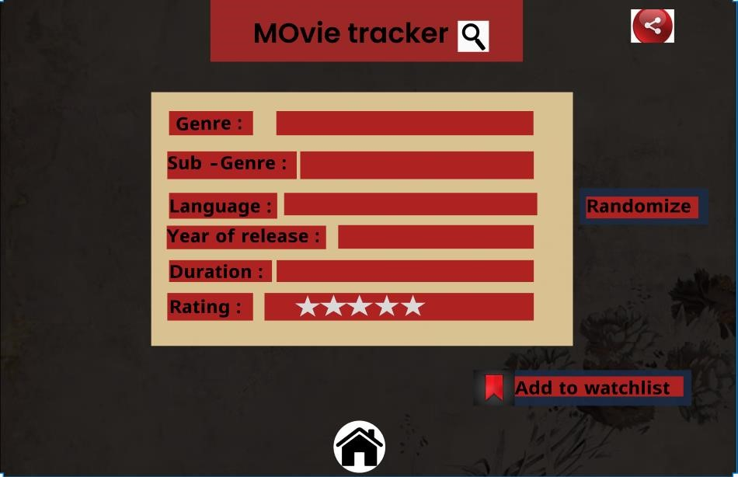

GOOD DESIGN:

